**APPLICATION: MEDICAL (RADIOLOGY IMAGING APP)**

**USERS MANUAL**

**ABOUT THE APPLICATION**

The radiology imaging application is a web application, which serve the purpose of having the medical, radiology test and result accessible to the patience anywhere anytime. This will serve a way to reduce reoccurrence test to be taken and save cost of medical image test.

**THE FEATURES OF THE APPLICATION**

* Login page.
* Sign up page.
* Patient access domain.

User can book appointment with the doctor, go for test and receive the test result.

* Doctor access domain.

Access to Patient data, create test for the patient, communication with the radiologist, view patient test result and present it to the patient for further treatment.

* Radiologist access domain.

Access to Patient data view test request from the test, do a test, send the test result to the doctor.

**IMAGES AND DESCRIPTION**

**Login page for all users**

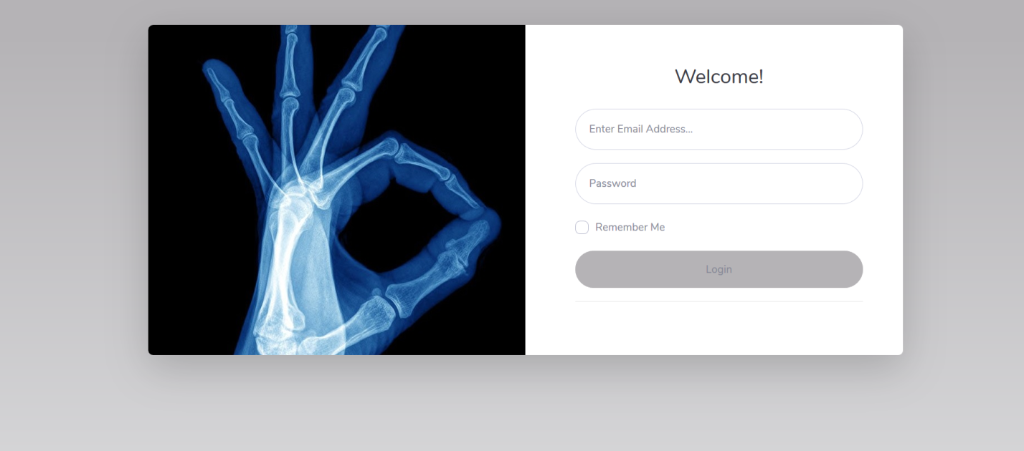

**For Doctor**

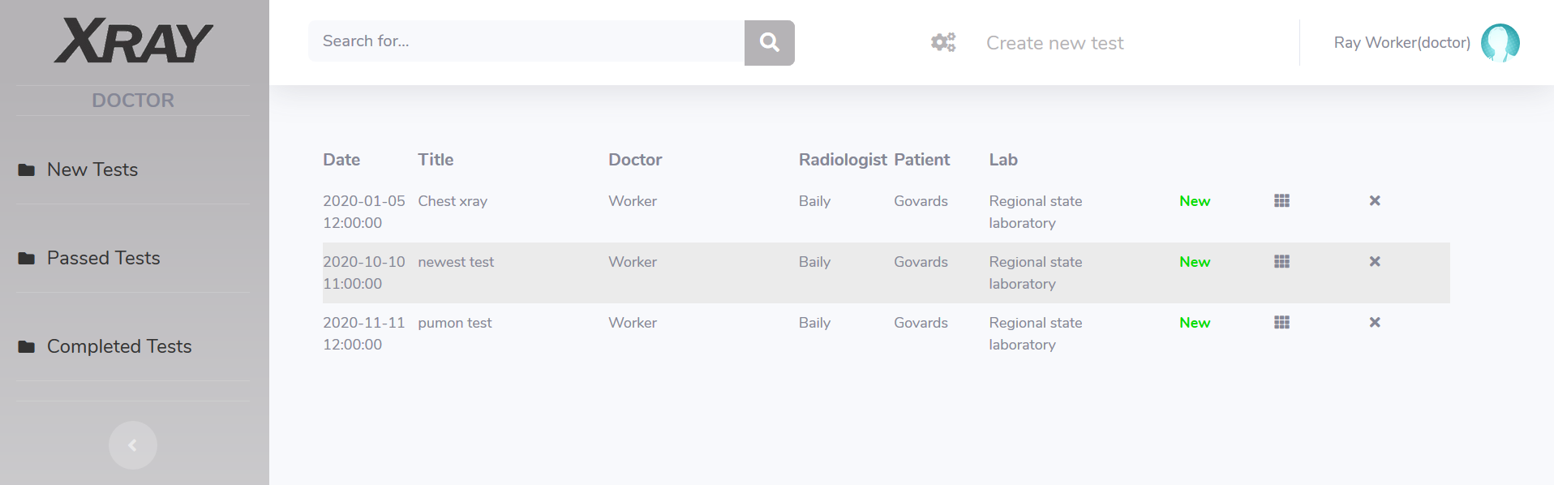

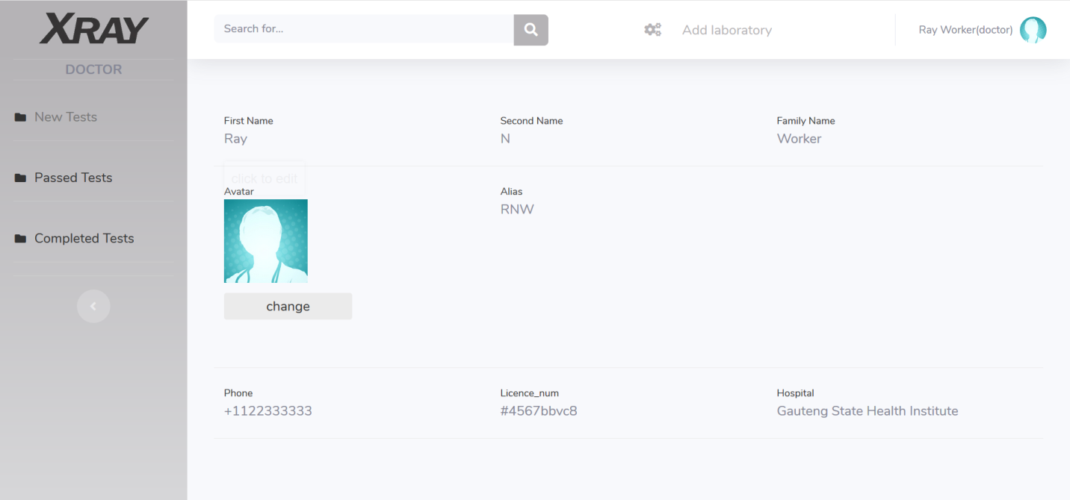

**For Radiologist**

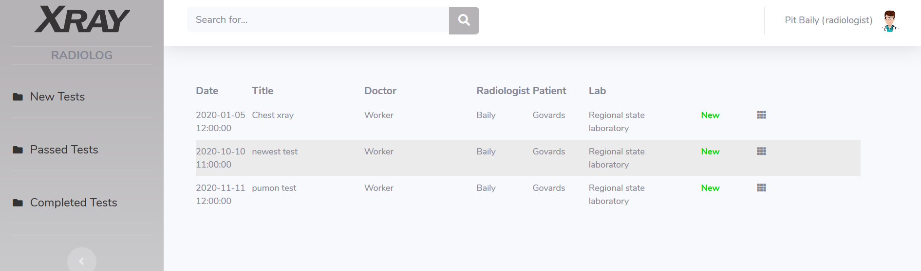

**For Patient**

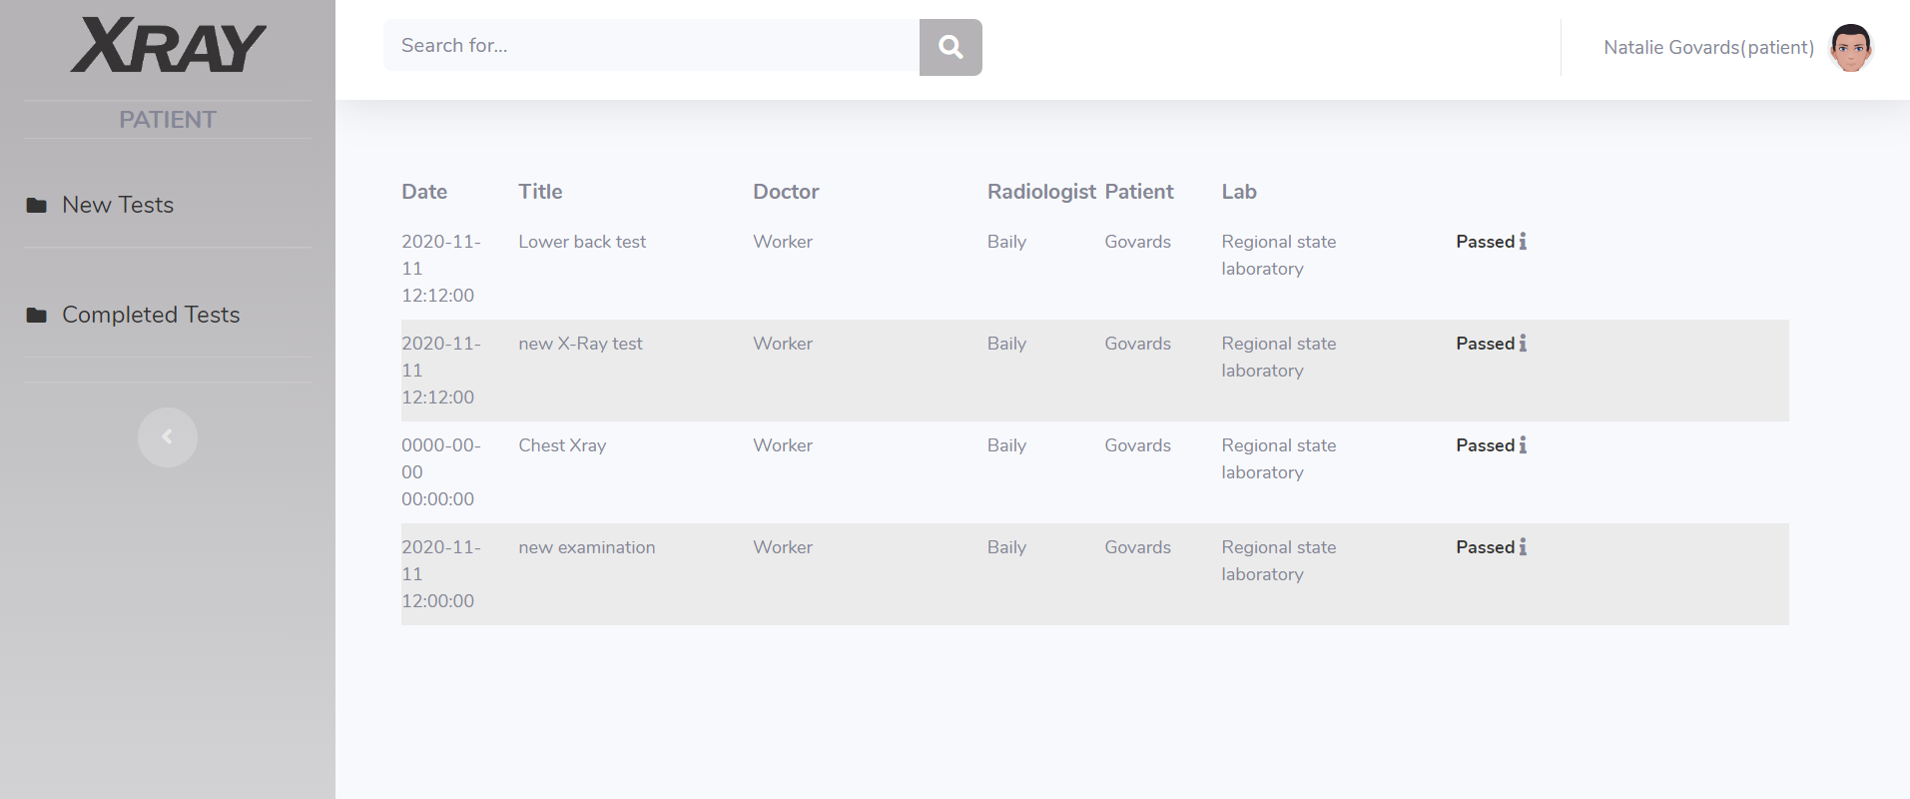

* **SECURITY**

There’s OTP function for security, the otp is sent to the associated email address on the profile.